Project Design Group 1

Currency Conversion Application

UMGC CMSC 495 Section 6380

Elizabeth Bloss

Jackson Perry

Carl Blocker

Jonah Kiplimo

User interface and functionality

Group one has built an intuitive and secure UI for the currency conversion application, It allows users to get a near real time conversion between more than a hundred currencies as well as some popular precious metals and cryptocurrencies. The user interface is web based and can be access from any browser on a computer or mobile device. Features include;

* Drop down menu for target currency
* Drop down menue for source currency
* convert button
* conversion output text box
* history button, that will display the last ten conversions any user has run

Application Structure

The application it self will consist of the main components, a web interface to allow the user to interact with the application, this will be formatted in HTML with CSS, tailwinds, and HTMX the next piece is the backend that will make calls to a conversion API to get current rates in USD and make conversions. The backend will be written in python with flask. The third piece will be a Postgres database to capture user interactions and cache data. The database will be interacted with with SQL.

Production Environment

The application needs a reliable and secure deployment environment to ensure reliable and safe operation. The target will require the following features:

* Firewall with SSL certificates Pfsense running on FreeBSD on a dedicated hardware
* Reverse Proxy with SSL offloading, HA Proxy
* Virtualization/hypervisor, Proxmox cluster
* Docker host, Debian Virtual machine.
* Webserver, gunicorn
* Postrges Database, Debian Virtual Machine or LXC container

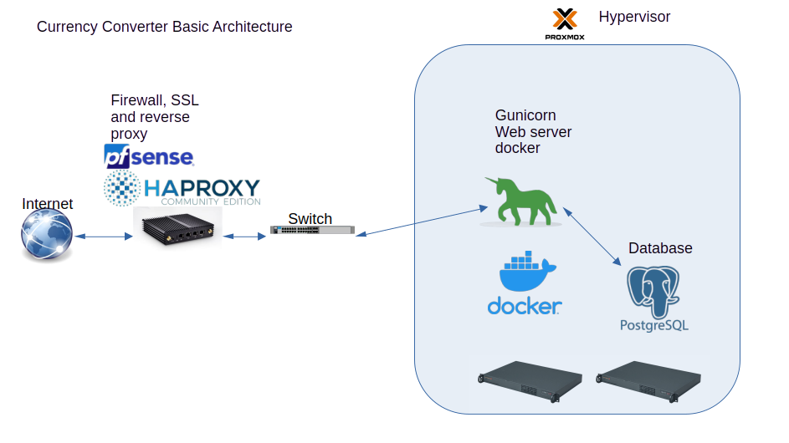

UML Classes:

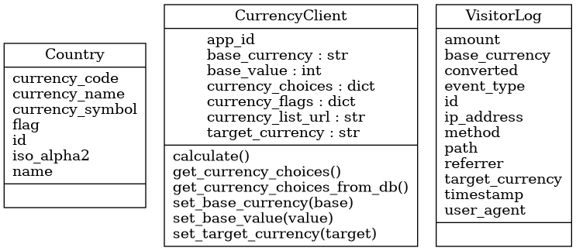

Packages relationships:

